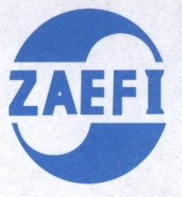

**深圳外商投资企业协会**

**公平贸易工作站**

**How to protect the supply chain safety in International Trade**

**--- Supply Chain Management**

As for high-speed expand of globe trading, kinds of crimes penetrate into supply chain continuously as well. Accompany the increase of diversify laws and principles come out, companies and organizations pay more attention to the safety of supply chain in the past 10years. Whereas, to protect the complete and safety of logistics-supply chain, become more and more important cases for enterprises.

Therefore, Shenzhen Association of Enterprises with Foreign Investment (SZAEFI) will cooperate with SGS to hold a professional training and sharing related topics as follow:

New trend of supply chain safety

Brief introduction of C-TPAT, and influence for USA

TPAP FSR/TSR

ISO 28000

Case sharing

**Time:** at Pm2:30; August31,2021;

**Way of learning:** On-line

**Fee:** For free

**For detail, please contact:**

Yomi Chan: 83661186、13826577613

Ms. Huang: 83661516、13641437527

Ms. Zhu: 83660140、13509665061

Ms. Zhou: 83660160、13714492547

**For booking please scan:**

